Overview of Suitable Wind Energy Zones in Syria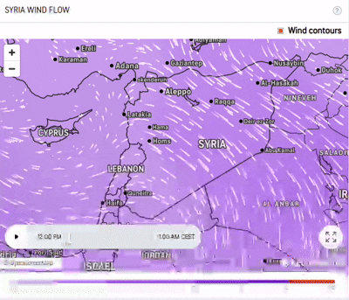
After a careful review of the Syrian wind map, five key regions with an average wind speed exceeding 5 m/s have been identified as favorable for wind energy investment:
- Coastal Mountain Region:
Extending from Idlib to western Hama and western Homs (referred to as “Shin”), this area exhibits good wind conditions. However, the complex terrain with extended mountain ranges, dense forests, and agricultural lands (such as orchards), along with high land prices, poses challenges for establishing wind farms.
- Central Region:
This zone stretches from the city of Qatena eastward to Palmyra, continues to western Deir ez-Zor, reaches eastern Raqqa, and then loops back through villages such as Al-Karom and Athria to Salmiya. Characterized by vast tracts of suitable and low-cost land (pastoral and desert areas), Qatena is considered one of the best sites for wind farms in the country. Despite surrounding areas being primarily agricultural with relatively high land costs, the proximity to the high tension electrical network and favorable wind conditions—peaking at 12 m/s during July and August—compensate for this, though wind speeds drop below 4 m/s for four months (from January to early March). Additionally, Palmyra ranks as the second most important location, despite its slightly lower wind speeds and weaker grid, because of the availability of extensive, low-cost lands.
- Area Around the International Road (Homs–Damascus):
Although the average wind speeds here are moderate (5–6 m/s at 50 m height), the region benefits from key advantages: its strategic location near the Homs–Damascus international highway, its closeness to high voltage lines (facilitating grid connection), and the abundance of inexpensive, open pastoral lands. The Jandar area, in particular, is noted as a promising site.
- Southwestern Region:
Extending from southern Damascus to Quneitra and into the Golan Heights, this region maintains wind speeds above 5 m/s throughout the year. Notably, near Quneitra (north of Al-Baath), the first wind turbine—with a capacity of 150 kW—was installed in 1994, underscoring the area’s wind potential.
- Southeastern Region:
Spanning from Damascus International Airport through areas like Saba’ Bayr and Al-Tanf down to Al-Zall on the Jordanian border, this zone benefits from good wind conditions. However, its relative remoteness from major road networks and the electrical grid currently diminishes its practical importance.

